RSJ 1.0

Project #000001

Carl Peaslee

April 4, 2016 / SOW Version #1

## Document Objective

The purpose of this document is to provide detailed documentation that clearly defines the work that Carl Peaslee will perform, the requirements and specifications under which that work will be performed, and the deliverables you will receive as a result of this project. By accepting this document you acknowledge your understanding and agreement to this scope of work. Any requirement which falls outside the specifications of this document will be considered “Out of Scope” and may require significant changes to the budget or timeline established for this project.

This document supersedes the estimate and any other documentation provided regarding the work to be performed by Carl Peaslee.

## Scope of Work Details

(For more detailed information regarding the history of and intentions for this project, read the [initial scope narrative.](https://docs.google.com/document/d/1cwFwfMBJYec3TyEG7p-R3u0ohsRwG-PuglnW2V2Yw4E/edit?usp=sharing))

Carl Peaslee will create a web application where users can create an account, share personal information in the form of journal entries and question responses, and read from an interactive digital novel.

The book pages will be presented in a user-friendly and adaptive format –– in particular the site should be especially well suited for use on ipad.

## Overview of Components

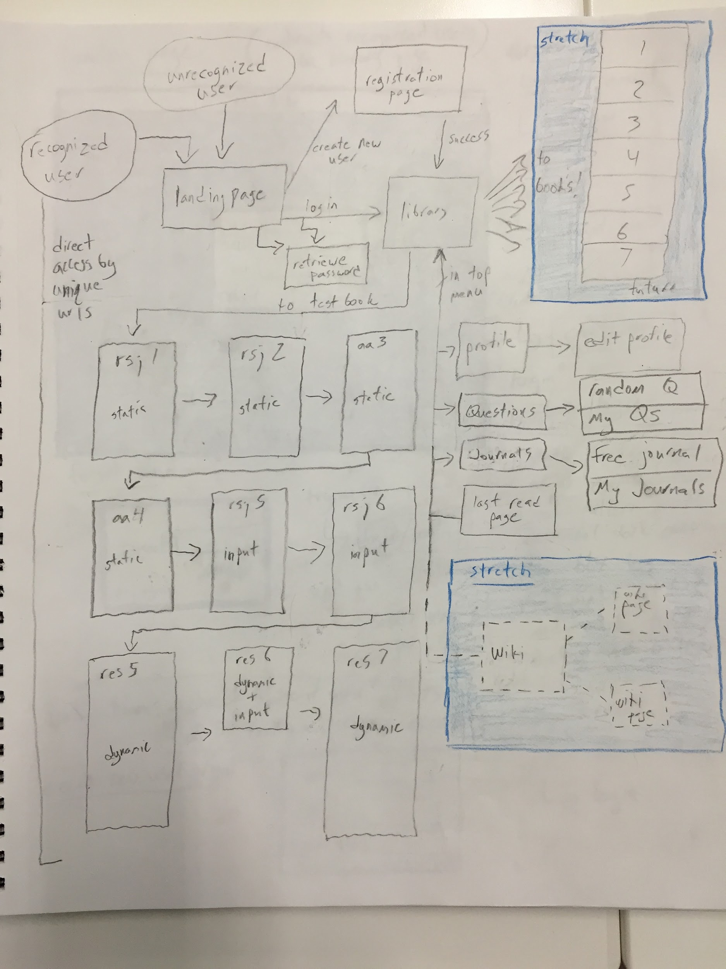

* landing (page)
  + login (view)
    - login (form)
      * username // *STRETCH email* (input)
      * password (input)
      * login (button)
    - new user (link)
    - *STRETCH “I forgot...” (link)*
  + new user (view)
    - create new user (form)
      * email (input)
      * confirm email (input)
      * password (input)
      * confirm password (input)
      * create (button)
* main site (page)
  + main menu (major component)
    - profile (link)
    - questions (link)
    - journals (link)
    - back to the book (link)
  + library (view)
    - book display (display box)
      * test book (item in display)
        + title (text)
        + book subheader (text)
        + cover photo (photo)
        + read (button)
  + profile (view)
    - my profile (tab)
      * email (text)
      * first name (text)
      * last name (text)
      * address (text)
      * address2 (text)
      * city (text)
      * state (text)
      * zip code (text)
      * phone number (text)
    - *//STRETCH: edit profile (tab)*
      * *email (input)*
      * *first name (input)*
      * *last name (input)*
      * *address (input)*
      * *address2 (input)*
      * *city (input)*
      * *state (input)*
      * *zip code (input)*
      * *phone number (input)*
      * *save profile (button)*
  + *STRETCH questions (view)*
    - *random question (tab)*
      * *prompt (text)*
      * *response (input)*
      * *save (button)*
      * *skip (button)*
    - *my answers (tab)*
      * *list (list)*
        + *question (text)*
        + *answer date (text)*
        + *my response (test)*
        + *associated page (link)*
  + journals (view)
    - free write (tab)
      * title (input)
      * entry (input)
      * save (button)
    - my entries (tab)
      * list (list)
        + submission date (text)
        + title / prompt (text)
        + entry (text)
        + associated page (link)
  + last page read (link)
* test book (book view)
  + test page, style 1 – basic
    - header
    - body
    - footer
  + test page, style 1 – input
    - header
    - input
    - footer
  + test page, style 2 – basic
    - header
    - body
    - footer
  + test page, style 3 – dynamic, basic input
    - header
    - body
    - input
  + test page, style 3 – dynamic, complex input
    - header
    - body
    - input

### [Landing](https://drive.google.com/open?id=0Bz8aQVY-BBE-enR4Si1GSV9GRE0)

This page is the first page users will reach when they navigate to the site –– if they are already logged in, they will be forwarded to their library or allowed to navigate to a specific link.

#### Login

Users may enter their email and passwords into the form and then press a button to login. They may also click a link to create a new account.

#### Create New Account

Users can create a new account by entering their email, confirming it, entering their email, confirming it, and pressing submit. They will be logged in after they do this.

### Main Site

The majority of the site will be considered the main sight. It’s central components are the main menu and whichever view the user has navigated to

#### [Main Menu](https://drive.google.com/open?id=0Bz8aQVY-BBE-bS1HdFh4WVBkX00)

This is the central navigational tool for users. There will be an expand button located in the upper left corner of the site and the menu will expand out along the top of the site when the button is clicked. This feature is a fabtoolbar from material design. The menu will have five options:

* Profile
* Library
* Questions
* Journals
* Continue Reading

#### [Library](https://drive.google.com/open?id=0Bz8aQVY-BBE-bS1HdFh4WVBkX00)

This page displays all the books “owned” by the user. Each instance of a book will take the form of a Material Design Card. Each card will feature the book’s title, subtitle, cover photo, and a button that says “Read”. Pressing the button will take the user to their farthest read page in that book.

#### [Profile](https://drive.google.com/open?id=0Bz8aQVY-BBE-Y1JRTkkzYTBIRlE)

This page will feature two Material Design tabs:

##### View Profile

This is where the user can view their profile information. The information will fill disabled Material Design Forms.

##### Edit Profile

This is where the user can edit and save their profile information. The information will be in editable Material Design forms. There will be a save button at the bottom.

#### [Questions](https://drive.google.com/open?id=0Bz8aQVY-BBE-NG1lRW1rY2Ywb3M)

This page will feature two tabs:

##### Random Question

This tab presents the user with a question and input field. The question is taken randomly from a database. A “Save” button will allow the user to save a new response and then present that user with a new random question. The user may also press the “Skip” button which will bring them to a new random question.

##### View Answers

This page will allow the user to see the responses they have given, both to the random questions and also to the questions they were posed while they were reading the interactive novels. This information will be represented using a Material Design List.

#### Journals

This page will have two Material Design tabs:

##### Free Write

This tab presents the user with “title” and “entry” Material Input fields. A “Save” button will allow the user to save a new entry.

##### View Entries

This page will allow the user to see the entries they have submitted, both from their free writes and also those from the prompts that were posed to them while they were reading the interactive novels. This list will be represented using Material Design Lists.

#### Last Page Read

This menu item will navigate a user to the last page they were reading in the novels.

### [Test Book](https://drive.google.com/open?id=0Bz8aQVY-BBE-YU5pSkdZOEhXZnc)

Each page of the book will have a unique url based on its book and page number information. Page headers, bodies, interactive features, and footers will be taken from the book database.

## Deployment Plan

Fill in ALL available information in the following list. Be as specific as possible.

* This app will use the latest versions of: node, passport, body-parser, express, angular, angular routing, angular animation, angular aria, angular materials, mongodb, and mongoose
* Carl Peaslee will be deploying it to heroku.

## Project MILESTONES

|  |  |  |
| --- | --- | --- |
| Scope of Work Approved |  | 4/4/2016 |
| Menu Bar |  | 4/4/2016 |
| All Non-Book Pages |  | 4/4/2016 |
| Login |  | 4/5/2016 |
| View/Edit Profile |  | 4/5/2016 |
| View/Edit Questions |  | 4/6/2016 |
| View/Edit Journals |  | 4/6/2016 |
| View Test Book Pages |  | 4/8/2016 |
| Test book pages are formatted for ipad |  | 4/11/2016 |
| Interactive test book pages send information to DB |  | 4/12/2016 |
| Dynamic test book pages change based on user actions/information |  | 4/14/2016 |
| QA testing |  | 4/15/2016 |

## Supported Browsers & Devices

### Browsers

Application will fully support only the below listed browsers and QA will test only in the following browsers and versions. All browsers or versions not listed below are considered out of scope.

|  |  |  |  |
| --- | --- | --- | --- |
| BROWSER NAME | VERSION | TYPE | SUPPORT |
| Chrome | most recent |  | full |
| Safari mobile for ipad |  |  |  |
|  |  |  |  |
|  |  |  |  |
|  |  |  |  |
|  |  |  |  |

*Full support is defined as “All scoped and designed features will function as defined”*

*Progressive support is defined as “The product will be compatible with this browser, but certain features based on the browser's limitations may not be fully functional. Unless covered by the scope, the site/app will also not be pixel perfect to the original designs.”*

*Supported browsers are assumed to be the versions listed without any add-ons, plug ins, or customizations.*

*Chrome and Firefox browsers update on release channels frequently and automatically. Versions to be tested will be at the time of writing of this scope of work. Defects or functionality changes introduced due to updates to these browsers during the development of this project may not be tested or supported, and may require a scope change to address.*

### Devices

Application will fully support only the below listed devices and QA will test only in the following devices and operating systems. All devices and operating systems not listed below are considered out of scope.

|  |  |  |  |
| --- | --- | --- | --- |
| MANUFACTURER | DEVICE NAME | OS VERSION | SUPPORT |
| Apple | iPad | most recent | full |
|  |  |  |  |
|  |  |  |  |
|  |  |  |  |

*Full support is defined as “All scoped and designed features will function as defined”*

*Supported devices and operating systems are assumed to be the versions listed without any add-ons, plug ins, or customizations.*

*Native applications are tested on the hardware and OS listed. Mobile optimized sites are tested on the default, unmodified browser for the OS listed.*

## Pictures

